

**Wollo University**

**Kombolcha Institute of Technology**

**College of Informatics**

**Department of computer science**

**TitleFINAL PROJECT ACCIDENT INFORMATION MANAGEMENTSYSTEM FOR KOMBOLCHA CITY POLICE**

PREPARED BY 1.Siraj Mohhamed

2.Yordanose Kasshun

3.Tesfaye Admasu

4.Zekiy Seid

5.Tadese Adugna

Advisor’s name: -Instructor Yosef

Kombolcha, Wollo, Ethiopia

January 2018

## Approval

The Project is our own and has not been presented for a degree in any other university with this functionalities and all the sources of material used for the project/thesis have been duly acknowledged.

1.Sirag Mohammed ……………………………...

2.Yordanose Kasshun ………………………………

3.Tesfaye Admasu ………………………………

4.Zeki seid ………………………………

5.Tadese Adugna ……………………………..

This is to certify that I have read this project and that in my opinion it is fully adequate, in scope and quality, as a project for the degree of Bachelor of Science.

Name of Advisor ………………… Signature ………………………

Examiner Name Signature

1. Examiner 1 ………………………………….. ………………………
2. Examiner 2 …………………………………… ……………………….
3. Examiner 3 …………………………………… ………………………

## Acknowledgment

First of all, we would like to thank our almighty God, who gives us love, patience, healthy, wisdom and ability to walk through all the problems and obstacles during the period of our study. Our heartfelt appreciation for our adviser Instructor Yosef for his indefatigable guidance, valuable suggestion, moral support and constant encouragement in the documentation part and also instructor anteneh, for constructive opinions and willingness to participate in each part of our documentation and his effective direction. We also want to Thank inspector Getahun keberet ejegu and inspector Asmelash, who gave us information about Kombolcha police station that we are asking for our project.

Finally but not the least, we would like express our love, thanks, appreciation, and respect for the ongoing support of our parents and family members, for their continues encouragement and financial support. And also we would like to thank the teaching staffs of informatics who have contributed wholly to the success of this documentation.

Contents

Approval ii

Acknowledgment ii

Abstract x

Abbreviations x

Chapter One 1

Introduction of Whole Project Process 1

1 *Introduction* 1

1.1 Background about the organization 1

*1.1.1 Vision* 2

*1.1.2 Mission* 2

1.2 *Background about the project* 2

1.3 Statement of the problem 3

1.4 Objectiveof The Project 4

*1.4.1 General Objective* 4

*1.4.2 Specific Objective* 5

1.5 Feasibility Analysis 5

*1.5.1 Operation feasibility* 5

*1.5.2 Technical feasibility* 5

*1.5.3 Economic Feasibility* 6

Hardware development cost 7

Software cost 7

*1.5.4 Political feasibility* 8

*1.5.5 schedule feasibility* 8

1.6Scope and Significance of the project 8

*1.6.1Significance of the project* 8

*1.6.1.1 Beneficiaries of project* 9

*1.6.1.2 Benefits to police station* 9

*1.6.1.3 Benefits to Citizens* 10

*1.6.1.4 Benefits to Police Department* 10

*1.6.1.5 Benefits to Team member* 10

*1.6 .2 Scope and Limitation of project* 11

*1.6.2.1 Scope of project* 11

*1.6.2.2 Limitation of the project* 11

1.7 Methodology 12

*1.7.1 Data gathering Methodology* 12

*1.7.1 .1 Interview* 12

*1.7.1.2 Observation* 12

*1.7.1.3 Document Analysis* 12

*1.7.1.4 Analysis and Design Methodology* 13

*1.7.1.5 Development tool* 13

*1.7.1. 6 Implementation* 14

1.8 Team organization 14

1.9 Communication Means and Plan 15

Chapter Two 16

Description of the Existing System 16

*2.1 Introduction* 16

*2.1.1 File handling* 17

*2.1.2 Accident Detection* 17

*2.1.3 Report Generation* 18

2.2 Players in the existing system 19

2.3 Major functions/activities in the existing system 20

2.4 Explanation of the business rule of the organization 21

2.5 Report generated in the existing system 21

2.6 Bottleneck of the existing system 22

*2.6.1 Performance (Response time)* 22

*2.6.2* *Input (Inaccurate/redundant/flexible) and Output (Inaccurate)* 22

*2.6.3*  *Security and Controls* 22

*2.6.4*  *Efficiency* 23

2.7 Proposed solution for the new system 23

*2.7.1 Handling Files:* 23

*2.7.2 Accident Detection:* 23

2.8 Requirement Specification 25

*2.8.1Functional Requirements* 25

*2.8.2 Non-Functional Requirements* 26

2.9 Modeling the existing systems 28

*2.9.1. Essential Use Case Modeling* 28

 29

*2.9.2 Essential User Interface Prototyping* 30

*2.9.3 Essential User Interface Prototyping flow diagrams* 31

*2.9.4 Domain modeling with class responsibility collaborator (CRC*) 32

Chapter Three 35

System Analysis (Modeling the Proposed System ) 35

3.1 Introduction 35

3.2 Modeling proposed systems 35

*3.2.1* *System use case diagrams* 36

*3.2.2 Use case Description for each* 37

*3.2.3 Sequence Diagram* 58

*3.2.4 Activity Diagram* 64

*3.2.5 Class Diagram* 69

*3.2.6*  *User Interface Prototyping* 70

*The start-up strategy will be*: 97

**List of figures**

Figure 1 Use case Diagram of existing system 29

Figure 2 Essential User Interface Prototyping 31

Figure 3 User Interface Prototyping of flow diagram 32

Figure 4 use case diagram of proposed system 37

Figure 5 login sequence diagram 59

Figure 6 Dispatcher Sequence Diagram 60

Figure 7 Updating Database Sequence Diagram 61

Figure 8 Deleting Record Sequence Diagram 62

Figure 9 Accident Detection report Sequence Diagram: 63

Figure 10 Login activity diagram 65

Figure 11 Report generation activity diagram 66

Figure 12 Update Activity Diagram 67

Figure 13 Resource Activity Diagram 68

Figure 14 Logout Activity Diagram 68

Figure 15 class diagram 69

Figure 16 User Interface Prototyping 70

**List of Tables**

Table 1 Hardware Cost 7

Table 2 Software Cost 8

Table 3 Schedule Feasibility 8

Table 4 Development tools 13

Table 5 Team organization 14

Table 6 Class responsbility collabrator of dispacher 33

Table 7 class responsibility collaborator of field officer 33

Table 8 class responsibility collaborator of society 34

Table 9 class responsibility collaborator of Information desk 34

Table 10 Login discription 39

Table 11 adding user use case 40

Table 12 updating user account use case 41

Table 13 delete user account use case 42

Table 14 updating record use case 44

Table 15 deleting record use case 45

Table 16 adding record use case 46

Table 17 Emergency report use case 47

Table 18 open incident use case 48

Table 19 accident detection use case 49

Table 20 view posted information 50

Table 21 view request 51

Table 22 View accident file 52

Table 23 Change password 54

Table 24 allocate resource use case 55

Table 25 View report 56

Table 26 logout use case 57

## Abstract

The web based accident management system solves and minimizes so many problems on the organization. The system is with the client/server architected configuration. This means that there is a central application database to store data. This system uses SQL database engine to manage the data and it has the front end with the web programming language PHP. This system help for the employee of kombolcha city police station to communicate and also access their data easily. In general the system enables the transactions to be easier and faster.

The system activity flow seems the following. When an accident occurs in a society, the society informs the occurrence and other reliable information about the accident for the field officer. Then, the field officer informs the dispatcher by sending message on the form available on the website to detect the accident. After the dispatcher retrieves the detail information from the message sent by the field officer, he/she allocates resource.

## 

## Abbreviations

**AMS**: AccidentManagement system

**AIMS**:Accident information Management system

**KCPS**: kombolcha City Police Station

**SME**s:Subject matter expert

**OOSD**: Object oriented development

**OOA**: Object oriented analysis

**PHP:** Hypertext Preprocessor

**SQL:** Standard Query Language

## Chapter One

## Introduction of Whole Project Process

## 1 *Introduction*

The development of one country is analyzed from many direction or factors such as peaceful, security of the people and their property etc. Those are protected by accident management station such as police and society. The institution of accident management station is standing to protect peoples and their property from danger. Our project aimed to develop new web based accident management system. The proposed system applies to accident management institution all across the country and specially looks in the subject of accident management system of kombolcha city. It is well understood that accident prevention and detection of accident depend on highly responsive back bone to information management system. The efficiency of the accident controlling and the effectiveness with which it deals with accident depend on what quality of information it can drive or received from where the accident is occur and how fast it can have response to it.

## 1.1 Background about the organization

Kombolcha city police station is one of the institutions of accident management station on the given of this service there are many problem on the accident management that was established long years ago to give service to protect.

kombolcha city from accident. The station has responsible for receiving the accident sound and having quick response to the received accident sound and storing the nature of the accident, the location details, the sequence of the accident, information on victims. But this task is managed manually beginning from collecting and recording data about the accident and the technique of response to the accident. The accidents that can be reported can be either natural or human made. Some of theseare traffic accident, fire accident, killing or murder, flood, electric current accident, earth quake, harassment, etc.

### *1.1.1 Vision*

* To be one of the well organized and known service in Ethiopia and other developed countries.
* To increase the quality of service to society.
* To fulfill interest of society and increase communication with developed country.
* Satisfying the society.

### *1.1.2 Mission*

* To transfer useful and modern technology for the society.
* To give suitable and fast service based on society request.
* To increase the acceptance of the police stations.
* To increase the employee by supporting the technology.
* Finally they will consistently respond, fast and modern service, friendly service and great value that make society confident that kombolcha police station is the best police station.

## 1.2 *Background about the project*

Now a day, the introduction of new information systems is increasing at an alarming rate to bring radical change to the existing manual system, improve the performance of other systems and solve difficulties. Though this technology is new to our country Ethiopia and most of other developing countries, it was/is exploited well in developed countries, like Europe, India and America. The project is intended to advocate for the need of kombolcha city police station to use facilitated computerized and web based accident information management system. Because even if there is no organized accident management station in the city, the police station that give this service use manual way of information gathering and documenting, no reliable communication between different stations, as well as there is no optimized way to facilitate the service. So we are initiated to develop new web based automated system. As a result the team member believed that the user will have the expected satisfaction of the service provided by accident management system of kombolcha city police station.

Therefore the team member recommends to kombolcha city police station migrate the manual system to the computerized and web based accident information management system to facilitate their service that they give to the society.

## 1.3 Statement of the problem

In kombolcha city police station accident information management apply manual way of implementing tasks. The police station has the following problem:-

* Difficult of getting real information at real time when accident occurred that help to have real time response to accident.
* Difficult to manage the overall system.
* Accident file control mechanism is very tedious and complicated.
* Data redundancy and inconsistency.
* Difficult of communication of field office, society and the station to give and get real time response to the accident.
* Difficult to generate report.
* The officer lost the write information about the accident also loss accident information.
* Someone come from other place suddenly die in accident the person have not id or something about himself tell, Only thing is write report and stored it.
* Difficult of getting available resource to control and detect the accident at real time and to save human life and property since there is no organized detective in the system to control the accident rather than the society and police are tries to detect the accident as much as possible.
* Difficult in conducting consistent reports because the record is documented manually and require much time and human power to search and get wanted information (file).
* There is no fast and efficient way of sharing critical information across the station as well as with the external environment.
* The current system high work load for staff of police department.
* Also there is security problem as we mentioned before, the existing system is manually system in which document are stored in packed paper files so that the file are highly exposed to damage and can be stolen by any other unauthorized person or group.

## 1.4 Objectiveof The Project

### *1.4.1 General Objective*

The general objective of this project is developing new web based accident information management system for kombolcha city police station.

### *1.4.2 Specific Objective*

The specific objective of the accident management in kombolcha city police station include: -

* Investigating how the existing system is operation.
* Analyze the current system to design new data base system operated easily using web based system.
* Enabling the workers to communicate easily across the station and with their external environment.
* Reviewing how the current system works and operates.
* Forward the recommendation about system implementation.

## 1.5 Feasibility Analysis

Most of information system projects have budgets and deadlines, and analysis of factors for the feasibility forms the business case (analysis of assumptions like resource availability and potential problem and system costs and benefits) that justifies the expenditure on the project.

### *1.5.1 Operation feasibility*

The system to be developed will provide accurate, secured service and decrease the labor work load. Also the system will be easily operation, it does not affect the existing organization structure. So the system will be operation feasibility.

### *1.5.2 Technical feasibility*

General study in the project area has shown that the current technology and ability existing in order to complete the propose system objectives. Our project can be done with current equipment, existing software technology and available personnel and therefore it can be conclude that the system is technical feasibility.

### *1.5.3 Economic Feasibility*

The system to be developed is economically feasible and the benefit is out weighting the cost. Since this project already computerize the existing system by now the redaction of cost for materials used in manual operation becomes beneficiary to the organization.

Generally the system that we develop kombolcha city police station accident information management brought number of tangible and intangible benefits.The computerized system takes care of the present existing system’s dataflow and procedures completely and should generate all the reports of themanual system besides a host of other management reports. Depending onthis we are going to determine benefits of this project by dividing into two.Those are tangible and intangible benefits.

* + **Cost Benefit Analysis**

A) Tangible Benefits:-

According to our determination the project we are going develop will provide the next benefits as tangible benefits. Those are:

* Cost redaction:-to calculate the following things will be considered
* Cost reduction and avoidance
* Error reduction
* Increase speed of activity
* Decrease the cost give to employ.
* Increase the income of the organization.

The tangible costs to be acquired in developing the system are:-

* Require equipment with Costs which includes hardware development cost and other costs.
* Software development cost.

B) Intangible benefits:-

The benefits that we have determined under economic feasibility as intangible benefits are:

* Reduce Resource Consumption
* Increase security
* **Cost of the project**

### Hardware development cost

|  |  |  |  |  |
| --- | --- | --- | --- | --- |
| **No** | **Material** | **Amount** | **Unit price(Birr)** | **Total price** |
| 1 | HP CORE i7 | 1 | 10,000.00birr | 10,000.00birr |
| 1 | Paper (A4 ) | 2 packet | 180.00birr | 180.00birr |
| 2 | Pen (Bic5) | 5 | 5.00birr | 25.00birr |
| 3 | Flash memory (16GB) | 1 | 200.00birr | 200.00bir |
| 4 | CD-RW | 1 | 20.00birr | 40.00birr |
| 5 | Copy | - | 200.00birr | 200.00birr |
| 6 | Print | - | 300.00birr | 300.00birr |
| **7** | **Total** | | | **10945.00birr** |

Table 1Hardware Cost

### Software cost

|  |  |  |
| --- | --- | --- |
| **No** | **Material** | **Price per unit** |
| **1** | Microsoft office 2013 | 900 |
| **2** | Microsoft Visio 2013 | 800 |
| **3** | WampServer | 700 |
| **4** | Sublime | 3000 |
| **Total** | **5400.00 Birr** | |

Table 2Software Cost

### *1.5.4 Political feasibility*

The system to be developed is not conflict with any government directly or indirectly, because this new web based accident informationmanagement is give service for people effectively and efficiently.

SO the system will be political feasibility.

### *1.5.5 schedule feasibility*

The proposed system can be implemented in an acceptable timeframe given. Project manager is also responsible for monitoring & controlling the project development based on the schedule.

|  |  |  |
| --- | --- | --- |
| Tasks | Start | Finish |
| Project proposal | 01/04/2011 | 20/04/2011 |
| Requirement analysis | 21/04/2011 | 21/05/2011 |
| Design | 21/05/2011 | 21/06/2011 |
| Implementation and coding | 01/07/2011 | 01/08/2011 |
| Testing | 10/08/2011 | 30/08/2011 |

Table 3Schedule Feasibility

## 1.6Scope and Significance of the project

### *1.6.1Significance of the project*

* The new web based accident information management is system which is customized to the kombolcha city police station.
* The most important feature of the new system is that it is an accurate , easy and efficient system to detect accident as well as record accidental information such as date and time when the accident occur, location and level of the accident.
* Also cause and effect of the accident of the accident carefully recorded and documented.
* Simple and user friendly.
* It is enable searching the required information by using keys and also the main function of the system is sharing of information to the appropriate of different station.
* Report generation is done when necessary or required any time.
* Easy to maintain, fast, and accurate.
* Total number of each accident can be see easily.
* The can use English language.
* Learn society about they protect them self from accident.
* Generally, the purpose of this accident information management system is to solve all the problem of the organization and to satisfy the requirement of the people.

### *1.6.1.1 Beneficiaries of project*

### *1.6.1.2 Benefits to police station*

* Avoiding improper resource consumption like paper, pen.
* Avoiding data loss because of improper data storage
* Neat investigation files in the station can be transfers from generation to generation
* Enhance security mechanisms to protect crime records

### *1.6.1.3 Benefits to Citizens*

* Multiple channels to access services from police.
* Simplified process for reporting the accident.
* Can view posted information’s by the station anywhere at any time.
* Faster and assured response from police to any accident.

### *1.6.1.4 Benefits to Police Department*

* Enhanced tools for investigation.
* Facilitates fast and efficient retrieval of data.
* Can post necessary information to society easily.
* Reduced workload of the police station back-office activities such as preparation of reports and station records management.
* Can easily control the system.

### *1.6.1.5 Benefits to Team member*

* The team member can get additional knowledge.
* We can get degree of information system.
* Support the team member for next working.

### *1.6 .2 Scope and Limitation of project*

### *1.6.2.1 Scope of project*

This project will be developing new web based system for kombolcha city police station accident information management system. On completion of this project we expect the system will have:-

* With less effort and cost the system is able to maintain and store information.
* Accurate way of recording and storing information in to the database.
* Post information (post unknown people die in accident).
* Report are cannot be visible to society.
* Presence of centralized documented and organized record.
* Learn society they protect from accident.
* The system does not concern about the crime file management system.
* Facilitate timely management decision making and enable to have real time response to the accident detect it.
* Enabling the workers of the system to get reliable information where and when occurred as well as the type and level of accident to give reliable to response on detecting the accident.
* The can use English language.
* Total number of each accident can be see easily.
* They can be prepared report easily

### *1.6.2.2 Limitation of the project*

There are many constraints within our proposed system that limit their effectiveness of performance. Our system is limited only in the process of web based accident information management system of the kombolcha city police station, but does not include about crime file management system, the system depends on electric power and network connection .The above activities or subsystems are proposed system limitations because of the following reason

* TimeIs the main factor of limitation our proposed systems that limit its performance because while we are developing the system it takes more time and we may not get enough time to automate the system.
* Resourceswe have not laptop as an alternative when arbitrary failed the desktop and also when the power is off for a long time.

## 1.7 Methodology

### *1.7.1 Data gathering Methodology*

The requirement of the system is gathered using primary data collecting techniques. These are listed below.

### *1.7.1 .1 Interview*

* One of data gathering methodologies or mechanism we used to collect information by making a formal meeting at which we are asked some questions to kombolcha city police station manager and other member police as well as some peoples who live in the city.

### *1.7.1.2 Observation*

* Observation is the second data gathering methodology we used to collect information by direct watching some accidents inside the university and other traffic accidents when we are going to town by taxi.

### *1.7.1.3 Document Analysis*

Document analysis is used to understand how the system is working. We used this method to know all about the police station mission, vision, function and overall of their work in short and brief.

### *1.7.1.4 Analysis and Design Methodology*

In this project, our team will use object oriented system development methodology (OOSD) for the design.

This techniques has several phase some of them are-:

* Object oriented analysis (OOA):-during this phase the team uses to models the function of the system (use case modeling), finding and identify the business objects, organize the objective and identify the relationship between them and finally model the behavior of the objects in detail.
* Object oriented design (OOD):-During this phase our team uses Microsoft software to refine the use case model and rational rose for designing the sequence collaboration, activity diagrams and to model object interaction and behavior that support the use case scenario.

### *1.7.1.5 Development tool*

|  |  |
| --- | --- |
| Activities | Tools |
| Client side coding | HTML |
| Database Server | MY SQL database |
| Web server  Server Side Script  Browser | Apache server |
| PHP |
| Firefox 3.0, IE 5.5/6.0/7 etc…. |
| Editors | Sublime |
| Documentation | MS Word |
| Design | Visio |

Table 4 Development tools

### *1.7.1. 6 Implementation*

Implementation is a phase where all the work during analysis and design will be turned to a functional system. Prototype is divided into three sub phase: interface implementation, database implementation, and logical implementation. In interface implementation, we have tried to implement user- interface. Logical implementation implements the server-side functionality of the system. Generally we use partial because we use direct may affect the system so better is partial.

## 1.8 Team organization

The project team composed of 5 members, one team leader, one vice leader, one secretary, and 2 members .Problem solving is group activity. Decision on problem and approach are made by group agreement, which is much better than individual decision.

|  |  |  |  |
| --- | --- | --- | --- |
| Project Title | ACCIDENT INFORMATION MANAGEMENT SYSTEM FOR KOMBOLCHA  CITY POLOICE STATION | | |
| PREPARED  BY | ID NUMBER | NAME | RESPONSIBILITY |
|  | WOUR/2024/08 | SIRAG MOHAMMED | -Group Coordinator  -documentation, implementation |
|  | WOUR/2065/08 | YORDANSE KASSAHUN | -V-coordinator  -Designing and  Testing  docmentation |
|  | WOUR/1374/07 | TESFAYE ADMASU | -Secretory and coding  -Testing  ,documentation |
|  | WOUR/2068/08 | ZEKIY SEID | Analysis/  Requirement  Gathering |
|  | WOUR/2028/08 | TADESSE ADUGNA | -Testing  -give an idea |

Table 5 Team organization

## 1.9 Communication Means and Plan

While we are working our project, we use the following means of communication in order to meet one another and with our advisor to exchange suggestions and ideas. Those techniquesare we were using to communicate in Mobile Phone,Email, Plus telegram and also some other social medias.

We have a plan to communicate each other four days (Monday, Wednesday, Thursday, Saturday,) in a week. And also an advice time with our advisor one day (frieday) in a week.

## Chapter Two

## Description of the Existing System

## *2.1 Introduction*

In this chapter we studied the existing system deeply, since it is necessary to know the existing working system of office so as to develop a better system. When we studied the existing system we gave emphasis for here under listed questions:-

* How the existing system is working?
* What kind of method they use to handle accident data?
* In what way the police office is handling accident information managed?
* What is the business rule they use?

After studying the existing system, we also determined the requirement or the feature that must be included in the proposed system. Furthermore by analyzing the current system, we could also estimate how the propose system solve the setbacks of the existing system.

kombolcha city police station offers many services for the society of the city and around the city.

There is 7 main department in this institution:-

* Follow up criminal information.
* Buying and finance administration Supporter.
* Road traffic security acknowledgment.
* Criminal examination.
* Police service.
* Human resource furtherance.
* Society include police service.

The current system generally performs the following task:

* Collecting information about any accident occur in and around the city based on the received information about the accident.
* It allocates resource.
* Detect the accident.
* Recording and documenting all necessary information about the accident manually.
* Generate report about accident if required by any private and government institution according to their request that may want to support societies that do not suffer from the accident and protect peaceful security and properties of the society from danger.

### *2.1.1 File handling*

They record their file of accident report, daily, weekly, monthly, 3 months, 6 months, yearly reports and other information related with accident on paper. If they want to update files and records, the searching activity is very tedious and boring. The format of file recording is not consistent.

### *2.1.2 Accident Detection*

There are 12 sub-stations in KCPS. They are placed in each Kebele. Theyare:01,02,03,04,05,06,07,08,09,10,11,12.

From these stations the main station is found in kombolcha city administration police secretariat. Even though accident detection is duty of all human beings, there are especially responsible persons for this activity organized by the government. These responsible persons are polices. Polices has different level of power, such as commander, inspector, sujine, and other lower level polices.

Currently they are around 121 polices that are involves in accident information management system.

When one accident occurs in one kebele, the people inform that accident for the police located around that kebele. Then these polices tell for the field officers. The field officer reports that accident for the dispatcher in the main station. The dispatcher then checks the availability of resources. If resources are available, he/she allocate these resources and send the accident controlling team to the place of the accident. Else if there is no available resource, they take any of individual or private resources that are useful to manage the accident, from any place if they are free to use. In KCPS, there is no organized accident controlling team for each accident type. So, they request help from other organizations which are responsible and which have ability to manage that accident. If the resources available in the sub-station are not enough to manage that accident like have not jail, they transfer that report for the KCPS.

### *2.1.3 Report Generation*

Each station prepares and presents report daily, weekly, monthly, in 3 months, in 6 months, and per year for the main station KCPS. In the same way the main station of the city prepare report based on the reports collected from the sub-stations and presents it for the main station. Daily reports can be by paper, if the substation is near to the main station or simply by using telephone or radio if it is not possible, but weekly and further longer time reports would be reported with paper and all data would be given to the information desk controller.

## 2.2 Players in the existing system

The existing system enables the Field officer

* If the field officer exist in accident place report accident.
* Call to police station and he/she need additional resource.
* Directly work with society.
* Collect all necessary information note book.

The existing system enables the society

* If society see the accident happen directly report the accident
* He/she report in two ways either in telephone or physically going to police station.
* Send their comment either in oral or written form.

The existing systems enable the Administrator/Dispatcher

* The dispatcher accept the emergency accident report automatically assign resource and notify to accident control team.
* View previous accident report
* Update previous accident report.

The existing systems enable the Accident controlling team:

* Accident report the dispatcher sends the accident report the go to place and prepare the report.
* Prepare the report.
* Learn how to protect from accident for society.

The existing systems enable the Information Desk to

* Retrieve data and give appropriate information to user and dispatcher
* Document and organize daily report come from Field officer and accident controlling team with the final modification.

## 2.3 Major functions/activities in the existing system

A, Report Emergency accident:-in the existing system the emergency accident reported in three way. First is society calling telephone to police stations.Most time the telephone is busy because the police stations have only one telephone. Second the society come to police station in physically,third radios.

B, Generate report**:-**the report prepared in day, three day weeks, month, three month, six month, year report. This report is major report generate time. All report generate is very tedious and complex because all thing is done in manually so difficult to prepared report, specially the month, three month, six month, year report are more difficult and additional task to police department to search the file.

C, Store the accident file:-the existing system store the accident information in manually. This method is not secured, also have not backup and not organizid. The accident file only in one document if the paper damage also damage the accident file.

## 2.4 Explanation of the business rule of the organization

A business rule of existing system is successfully an operating standard or policies that will explain for existing system of kombolcha police station.

The existing system has many business rules or principles some of them are:

**Br1:** New accident reports (first information reports) have to received and organized by accident control team.

**Br2:** Emergency accident should get fast response as much as possible like human life.

**Br3:** accident file should be investigated by Accident control team.

**Br4:** The accident should be happened in kombolcha city or around the city, in order to start investigation process.

**Br5:** any accidental emergency should be reported in 24 hours

**Br6:** society had right to report any accident

***Br7:*** Dispatcher police officer should work for 24 hours to accept accident reports

## 2.5 Report generated in the existing system

Each station prepares and presents report daily, weekly, monthly, in 3 months, in 6 months, and per year for the main station kombolcha city police station. In the same way the main station of the city prepare report based on the reports collected from the sub-stations and presents it for the Zone station. Daily reports can be by paper, if the substation is near to the main station or simply by using telephone or radios if it is not possible, but weekly and further longer time reports would be reported with paper and all data would be given to the information desk controller.

## 2.6 Bottleneck of the existing system

In kombolcha city police station accident management apply manual way of implementing tasks. It will be face many technological problem to site some this multiphase factors in the case of police station are the following problem :-

### *2.6.1 Performance (Response time)*

* Difficult of getting real information at real time when accident occurred that help to have real time response to accident.
* Difficult of communication of field office, society and the station to give and get real time response to the accident.
* System has work load for police department.

### *2.6.2 Input (Inaccurate/redundant/flexible) and Output (Inaccurate)*

* Difficult to generate report
* Difficult in conducting consistent reports because the record is documented manually and require much time and human power to search and get wanted information (file).
* Data redundancy and inconsistency

### *2.6.3 Security and Controls*

* Difficult of getting available resource to control and detect the accident at real time and to save human life and property since there is no organized detective in the system to control the accident rather than the society and police are tries to detect the accident as much as possible.
* Difficult to manage the overall system.
* Someone come from other place suddenly die in accident the person have not id or something about himself tell, Only thing is write report and stored it.
* Accident file control mechanism is very tedious and complicated.

Also there is security problem as we mentioned before, the existing system is manually system in which document are stored in packed paper files so that the file are highly exposed to damage and can be stolen by any other unauthorized person or group.

### *2.6.4 Efficiency*

* There is no fast and efficient way of sharing critical information across the station as well as with the external environment.
* The officer loss the paper that write the report is also loss the information about the accident.

## 2.7 Proposed solution for the new system

The proposed accident management system has global functionality, but it is optimized to kombolcha city police station. This system solves all problems we have seen in the existing system.

### *2.7.1 Handling Files:*

When we start from file handling, they it every accident record in a database. So, the dispatcher can simply access i.e. searching, updating, or deleting the records; it also make the system secured from illegal or unauthorized users or persons.

### *2.7.2 Accident Detection:*

After the development of kombolcha city police station website, each sub-station can report the accident and send any other necessary information or other requests on the internet for this organization by filling all the necessary or detail information on the designed forms. Then the dispatcher sends acknowledgment for these substations.

Then he check the availability of resources on the system and then he/she send the accident controlling team to the place of accident to manage the accident in a short time before the lose life and property occur on the society.

In general term the new system will eliminate/ reduce the problem on time accuracy, security issue, and complexity and information distribution. The system will include a centralized data base for accidental data records that facilitate fast information retrieval, modifying, inserting and deleting and also improve the communication among administrator, field officer, information desk and Accident controlling team. It also includes an attractive user interface that facilitates accessing the database and recording accidental data easily. The proposed system will provide:-

* Greater efficiency for recording investigation file***:***Since the proposed system uses database system, registering investigation files, and updating of progress files from the database will be easy and also there will not be loose of data.
* Security*:* since the proposed system requires verification of logon form, sensitive information’s will not be accessed or modified by unauthorized users.
* Better service: since the proposed system allows users to report online without a need of going to police station, there will be fast response for accident. Users will also view all posted information’s from anywhere.
* Efficient retrieval of accident files**:** since the proposed system record each and every accident file on the data base, retrieval of accident files from the database at any time will be a very easy process.
* Efficient accident management: in the proposed system polices can view and easily control the system are work well and control all accident information.
* Increase Operational Efficiency**:** The proposed system should help in reducing the repetitive paperwork/records and making the back-office functions more efficient.

## 2.8 Requirement Specification

### *2.8.1Functional Requirements*

The new system will be a networked application that will run on client -server and to provide case to use user interfaces to the users and window server for the server side application. The new system will also perform record management function that the system should record all the modifications on the record management system.

All in all the functionalities that will be provided by the system are the following.

* The system enables the Field officer
* To generate emergency report and to send to the Dispatcher
* To get acknowledgment and notification from the Dispatcher
* To report whether the team detect the accident or any additional resource is required to the dispatcher
* To retrieve and to modify previously generated emergency report
* The system enables the society:
* To generate emergency report and to send to the Dispatcher.
* To get acknowledgment and notification from the Dispatcher.
* The system should enable the Administrator/Dispatcher:-
* To open accident reports come from field officer.
* To notify the field officer that he/she receive the report.
* To get report about amount and type of resource currently available.
* To suggest the shortest path route.
* To modify previously generated accident detection process.
* To communicate with the accident controlling team and field officer until the accident is managed.
* The system should enable the Accident controlling team:-
* To get and respond to notification come from the dispatcher
* To generate general report about the controlling situation of the accident including the effect of the accidents
* To suggest the shortest path route
* The system should enable the Information Desk to:-
* Retrieve data and give appropriate information to user and dispatcher
* Document and organize daily report come from Field officer and accident controlling team with the final modification.
* Archive the data relative to duration they created.
* Provide current information about the resource and which detective is free.
* Posted people unknown people die in accident: this very important for new system because someone come other place then sudenly die in accident. The person has no id or something about himself. So the systems post this person.

### *2.8.2 Non-Functional Requirements*

Non-functional requirements describe user-visible aspects of the system that are not directly related with the functional behavior of the system. These requirements do not directly affect the performance of the system but are nonetheless important .They are concerned with security, performance, internationalization, usability, maintainability, reliability, modifiability, efficiency, portability across operating systems, testability, understandability. Generally the non-functional requirements of the system are presented below:

1. Speed: The system will perform at 1 second or less at normal circumstances while appending and retrieving data to and from the database respectively (i.e. when networks and nodes are ok).
2. Reliability: **T**he system allows reliable communication between the main station with sub-stations, and society. It also allows reliability while searching and displaying data from the database, while appending data in the database and data are passed to the correct end user.
3. Security: The system database will be secured from accessed by any unauthorized person by making the login to the system only restricted to legal persons. We use strong password so it does not accessed by illegal person.
4. Quality: The system allows putting backup of data and it fulfills all user requirements**.**
5. User friendly interface Simple and interactive user interface components should be part of the system. This user friendly interface requirement of the system will be available in any end user and system administrator interface of the application.
6. Usability:The system provides a help and support menu in all interfaces or give direct input for the user to interact with the system.

The user can use the system by reading help and support.

1. Performance: Our system speed operation is very high. That means the accuracy and response time of

The system should be very fast.

1. Availability**:** The system should always be available for access at 24 hours, 7 days a week.

Also in the occurrence of any major system malfunctioning.

1. Reliability*:* The developed system should able to perform a required function under stated Conditions for a specified period of time.
2. *P*ortabili*ty:* The system supports every operating system.
3. Maintenance*:* New additional features can be added if required and also the system components i.e. memory, disk, drives shall be easily serviceable without much alteration in the code.
4. Back up*:-*The system should have back up using external hard disk. The backup is taken weekly.
5. Error handling*:* Our system handles error by showing the message” invalid input” when the user enter invalid input.

## 2.9 Modeling the existing systems

## *2.9.1. Essential Use Case Modeling*

Use case Diagram

We use this UML diagram to present the functionality of the system from the actor’s point of view. We use the use case model diagram to show graphically the system scope and boundaries as well as to represent the relationships between the actors and use cases. This UML diagram describes a function provided by the system that yields a visible result for an actor.

### 

Figure 1Use case Diagram of existing system

#### Participating Actors

* + - 1. Dispatcher or Dispatcher
      2. Information Desk
      3. Accident controlling team
      4. Field Officer
      5. Society

### *2.9.2 Essential User Interface Prototyping*

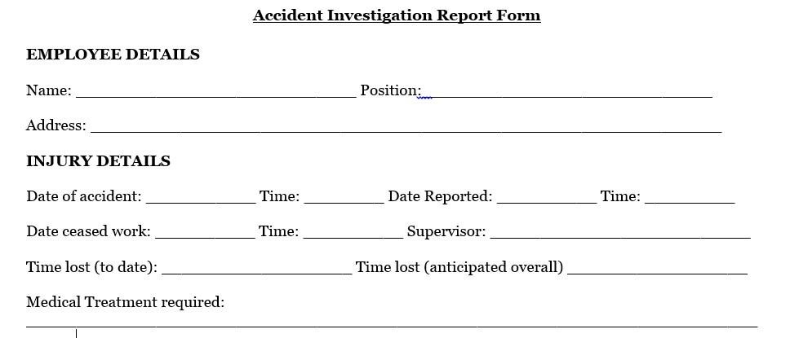

Date of incident: _______________ Time: ________ AM/PM

Accident/Incident Report Form

Name of injured person:

Phone

Number(s):

Date of birth: ________________ Male ______ Female _______

Who was injured person?(circle one) Passenger System Employee

Type of injury:

Details of incident:

Injury requires physician/hospital visit? Yes ___ No _____

Name of physician/hospital:

Address:

Physician/hospital phone number:

Signature of injured party

__________________________________________________________

Date

*No medical attention was desired and/or required.

Signature of injured party Date

Figure 2 Essential User Interface Prototyping

### *2.9.3 Essential User Interface Prototyping flow diagrams*

Accident

Controlling team

Infmatiom

desk

Soceity

Field officer

**Figure 3**User Interface Prototyping of flow diagram

### 2.9.4 Domain modeling with class responsibility collaborator (CRC)

|  |
| --- |
| *Dispacher <<Actor>>* |
| *Fname*  *Lname*  *Age*  *Gender*  *Allocate resource () information desk*  *Manage paper file () field officer*  *View request ()* |

Table 6Class responsbility collabrator of dispacher

|  |
| --- |
| *Field officer <<Actor>>* |
| *Fname*  *Lname*  *Age*  *Gender*  *Gather information ()society*  *Prepare report form () Accident controlling team*  *view emergency report ()* |

Table 7class responsibility collaborator of field officer

|  |
| --- |
| *society <<Actor>>* |
| *Fname*  *Lname*  *Age*  *Gender*  *Gather information () field officer*  *Inform accident () Accident controlling team*  *detect accident ()* |

Table 8 class responsibility collaborator of society

|  |
| --- |
| *Information desk <<Actor>>* |
| *Fname*  *Lname*  *Age*  *Gender*  *docmmenting () diparcher*  *stor file () field officer*  *view prepare file ()* |

Table 9class responsibility collaborator of Information desk

## Chapter Three

## System Analysis (Modeling the Proposed System )

## 3.1 Introduction

This phase helps to know what the system should do. You cannot successfully build a system if you don’t know what it should do.The greatest risk during this stage is that many people don’t want to investto elicit requirements instead they want to jump into right programming.Your Subject Matter Experts (SMEs) have their usual jobs to do and don’t have the time to invest. More over, your developers want to get into the “real work” of coding and senior mangers want to see some progress on the project, which usually means they want to see some code written. Here more time should be invested otherwise it’s risky (your effort here pay off in the long run)

## 3.2 Modeling proposed systems

##### *Participant Actors*

**Dispatcher:** has the following responsibilities :-

* Has direct access to the database
* Notifying field officer that it provide the report
* Allocating resource based on the emergency report come from field officer
* Announcing team to detect accident by having allocated resource
* Managing user account

**Accident controlling team:** has the following responsibilities :-

* Generate accident detection report which includes the process of accident control and effect of the accident.
* Studying cause of the accident

**Field officer:** has the following responsibilities:-

* Gathering information about the accident from the society.
* Generate emergency report
* Updating the report if any information is received

**Society:** has the following responsibilities:-

* Informing occurrence and cause of the accident
* Participating on detection of the accident
* Request for support to suffer from the accident

### *3.2.1 System use case diagrams*



Figure 4use case diagram of proposed system

### *3.2.2 Use case Description for each*

Use case description provides critical information needed to understand in what context the use cases are and briefly explain how the functionalties precede using natural language in a step wise manner. Here is the use case description for kombolcha city police station Accident information management system:

Use case: Login

|  |  |  |
| --- | --- | --- |
| Use case Name | Login | |
| UC_ID: | UC_01 | |
| Actor: | Dispatcher, field officer, accident controlling team, Information Desk | |
| Description: | This use case is used to ensure security for login into the system | |
| Precondition: | The user must have at least correct username and password. | |
| Flow Event: | Actor action | System response |
| Step1: User has to open the system.  Step3: by selects account type user fills his or her username and password.  Step4: click login button. Step6: the User gets access the system. |  |
| Post condition | The main page will be displayed then user gets access to its privilege and after finishing his/her work he can logout | |
| *Alternative course of action* | If they user is not authorized  A.6: The system gives a conformation that is wrong username or password | |

Table 10Login discription

**Use case: Adding user**

|  |  |  |
| --- | --- | --- |
| UC_ID: | UC_02 | |
| Actor: | Dispatcher | |
| Description: | It describes how to add a new user or account record in the system. | |
| Precondition: | the user should have logged in as Dispatcher | |
| Flow Event: | Actor action | System response |
| Step1: the dispatcher clicks on add user button  Step3: the dispatcher enters the new user name, account type, Password and reenter password to the system  Step 4: the dispatcher submits the new user information.  Step7:the dispatcher tells the category, user name and password to the user | step2:the system displays the form  Step5: the system validates the new user detail.  Step6: the system save the user detail to the database.  step7:the system displays successful message of adding new user  Step8:the system ends |
| Post condition | The new user information are added to the recorded | |

Table 11adding user use case

Use case: updating user account

|  |  |  |
| --- | --- | --- |
| UC_ID: | UC_03 | |
| Actor: | Dispatcher, field officer and accident control team | |
| Description: | It describes how the dispatcher(field officer or accident control team) modify the user database . | |
| Precondition: | the user should have logged | |
| Flow Event: | Actor action | System response |
| Step1: the Administrator wants to update an account and he/she login to the system.  Step2: the Administrator inserts account _type, username, password, and other user information.  Step3: the administrator submits the data. | Step4: the system checks the new account information with the existing account in the database. Step5: the system save the new account to the database.  Step6: the updating process ends |
| Post condition | The system modifies the records with the new entered data. | |
| Alternate course action: | 5.1: the system doesn’t save the new account to the system database  5.2: it displays a fill again message.  5.1: the system doesn’t save the new account to the system database  5.2: it displays a fill again message.  5.1: the system doesn’t save the new account to the system database  5.2: it displays a fill again message. | |

Table 12updating user account use case

Use case:-delete user account

|  |  |  |
| --- | --- | --- |
| UC_ID: | UC_04 | |
| Actor: | Dispatcher | |
| Description: | It describe how the dispatcher removes records of system user database. | |
| Precondition: | the user should have logged in as Dispatcher | |
| Flow Event: | Actor action | System response |
| Step1: the administrator wants to delete the account and he/she login to the system.  Step2: the administrator selects the delete button.  Step4:the administrator enters the account type and username of the user  Step7: the administrator selects the yes option. | step3:The system display a form Step5: the system checks the entered information with the existing account in the database Step6: the system sends message  “Do you want to delete?” to the administrator  Step8: the system delete the account from the system. Step  9 the use case ends |
| Post condition | The system removes the user details from the record | |
| Alternate course of action: | 5.1: the system displays try again message.  5.2:the system displays empty form  7.1: the system ends if he/she selects no. | |

Table 13delete user account use case

Use case updating record

|  |  |  |
| --- | --- | --- |
| UC_ID: | UC_05 | |
| Actor: | Dispatcher | |
| Description: | It describe how the dispatcher removes records of system user database. | |
| Precondition: | the user should have logged in as Dispatcher | |
| Flow Event: | Actor action | System response |
|  | Step1:the officer open  step3: the officer add the accident id or number step4: click on search button step7: The officer edits the form. step8: The user clicks on Update button. step11: the officer selects the yes option step14: end of use case | step2: The system will display search box step5: The system will check the accident id step6: The system will display searched result step9: The system checks the entered information step10: The system sends message” does u want to update?” step12: The system updates the information step13: the system displays successful message of updating |
| Post condition | The system saves the modified record to the database. | |
| Alternate course action: | 6.1: displays “try again” message.  6.2: the system will display empty search box  11.1: if the investigative officer select the no option, the system displays  ‘updating aborted’ message. | |

Table 14updating record use case

Use case: deleting records

|  |  |  |
| --- | --- | --- |
| UC_ID: | UC_06 | |
| Actor: | Dispatcher, information desk | |
| Description: | It is for dropping the content of the database. | |
| Precondition: | the user should have logged in as Dispatcher | |
| Flow Event: | Actor action | System response |
| Step1: the administrator wants to delete the record and he/she login to the system.  Step2: the administrator selects the delete button.  Step4: the administrator enters the accident type and accident number. Step7: the administrator selects the yes option. | step3:The system display a form Step5: the system checks the entered information with the existing account in the database Step6: the system sends message  “Do you want to delete?” to the administrator  Step8: the system delete the recorde from the system. Step  9 the use case ends |
| Post condition | The system removes the user details from the record | |

Table 15deleting record use case

**Use case: Adding record**

|  |  |  |
| --- | --- | --- |
| UC_ID: | UC_07 | |
| Actor: | Accident controlling team | |
| Description: | It describes how to add a new files or record in the system. | |
| Precondition: | the user should have logged in as accident controlling team | |
| Flow Event: | Actor action | System response |
| Step1: the accident controling team clicks on add record button  Step3: the accident controlling team enters the new records, data type, date and location to the system  Step 4: the accident controlling team submits the new record information.  Step7:the accident controlling team tells the category, file name and date etc to the user | step2:the system displays the form  Step5: the system validates the new records detail.  Step6: the system save the records detail to the database.  step7:the system displays successful message of adding new record  Step8:the system ends |
| Post condition | The new record information are added to the database | |
| Alternative |  | |

Table 16adding record use case

**USE CASE**: Emergency report

|  |  |  |
| --- | --- | --- |
| Use Case Name | Emergency report generate | |
| UC_ID: | UC_08 | |
| Actor: | Field officer, society | |
| Description: | There must be accident and collected information about it.. | |
| Precondition: | There must be accident and collected information about it. | |
| Flow Event: | Actor action | System response |
| Step1: The user open emergency form  Step3 The use write in the report form.  Step4:next click the emergency report button | Step2: system display the emergency report form.  Step5: the system check correctly write necessary information.  Step6: displays successful message to user.  Step7:send emergency report to Dispatcher.  Step 8 |
| Post condition | The system generated the report and displays successful message | |
| Alternate course action | 5.1: if not correct display try again message. | |

Table 17 Emergency report use case

**Use case:** Open incident

|  |  |  |
| --- | --- | --- |
| Use Case Name | Open incident | |
| UC_ID: | UC_09 | |
| Actor: | Dispatcher | |
| Description: | This is used to read the emergency report. | |
| Precondition: | The field officer must generate a new emergency report | |
| Flow Event: | Actor action | System response |
| **Step1:** the user wants to see the incident and she/he login to system.  **Step2:** The user select the incident page.  **Step4:** user see the incident. **Step5:** Notify accident controlling team the accident  **Step 6** send the notification to field officer and society. | **Step3:** system display incident reports.  **Step 7**:end use case |
| Post condition | Acknowledge field officer/society | |
| Alternate course action | 2.1: if not correct display try again message. | |

Table 18open incident use case

**USECASE:** Accident detection

|  |  |  |
| --- | --- | --- |
| Use Case Name | Accident detection | |
| UC_ID: | UC_10 | |
| Actor: | Accident controlling team, field officer and society | |
| Description: | This is handling of the accident by using allocated resource. | |
| Precondition: | Emergency report must be generated and resource must be available | |
| Flow Event: | Actor action | System response |
| Step1: officer report the accident to dispatcher.  Step2: the user wants to see the accident detection and she/he login to system.  Step2: The user select the incident page.  Step4: user see the incident. Step5: The dispatcher allocate resource and notify to accident controlling team.  Step6: Accident controlling team protects the accident. | Step3: system display incident reports.  Step 7:end use case |
| Post condition | Accident controlling team protects the accidents. | |
| Alternative action |  | |

Table 19accident detection use case

View posted information use case

|  |  |  |
| --- | --- | --- |
| Use Case Name | View posted information | |
| UC_ID: | UC_11 | |
| Actor: | Society/User | |
| Description: | This use case allows the user to see posted information’s | |
| Precondition: | there should be posted information’s | |
| Flow Event: | Actor action | System response |
| Step 1**:**the user wants to view the posted information’s step2**:**the user gets access to the system  **S**tep3**:**clicks on view post info button step5: the user view posted information’s  Step 6: the report process ends | Step4**:**The system displays posted information’s |
| Post condition | the user views posted information’s | |

Table 20view posted information

View request use case

|  |  |  |
| --- | --- | --- |
| Use Case Name | View request | |
| UC_ID: | UC_12 | |
| Actor: | Accident controlling team,field officer | |
| Description: | This use case allows this actors to see request | |
| Precondition: | there should be request | |
| Flow Event: | Actor action | System response |
| Step 1**:**the user wants to view the posted request  step2**:**the user gets access to the system  **S**tep3**:**clicks on view post info button step5: the user view posted request  Step 6: the view process ends | Step4**:**The system displays posted request |
| Post condition | the user views posted requests | |

Table 21view request

View accident file use case

|  |  |  |
| --- | --- | --- |
| Use Case Name | View accident file | |
| UC_ID: | UC_13 | |
| Actor: | Accident controlling team | |
| Description: | This use case allows the user to View accident file | |
| Precondition: | there should be posted accident file | |
| Flow Event: | Actor action | System response |
| Step 1**:**the user wants to view the accident file  step2**:**the user gets access to the system  **S**tep3**:**clicks on view accident file info button  step5: the user view accident file  Step 6: the view process ends | Step4**:**The system displays view accident file |
| Post condition | the user views accident file | |

Table 22 View accident file

Change password use case

|  |  |  |
| --- | --- | --- |
| Use Case Name | Change password | |
| UC_ID: | UC_14 | |
| Actor: | Accident controlling team | |
| Description: | This use case allows the user to change password | |
| Precondition: | there should password | |
| Flow Event: | Actor action | System response |
| Step 1**:**the user wants to change password  step2**:**the user gets access to the system  **S**tep3**:**clicks on change password button  step5: the user view changed password  Step 6: the changing process ends | Step4**:**The system displays changed password |
| Post condition | the user access from systems | |

Table 23Change password

USE CASE**:*allocate resource***

|  |  |  |
| --- | --- | --- |
| Use Case Name | ***allocate resource*** | |
| UC_ID: | UC_15 | |
| Actor: | System administrator(dispatcher) | |
| Description: | This is for providing resources to detect the accident. | |
| Precondition: | The field officer must generate a new emergency report | |
| Flow Event: | Actor action | System response |
| 1. Dispatcher opens incident 2. Send notification to field officer   Check availability of resources | Step2: The system point to resource location |
| Post condition | Notify accident controlling team the accident and show resources to it. | |

Table 24allocate resource use case

View report use case

|  |  |  |
| --- | --- | --- |
| Use Case Name | View report | |
| UC_ID: | UC_16 | |
| Actor: | disparchers | |
| Description: | This use case allows the disparchers to View report | |
| Precondition: | there should be posted report | |
| Flow Event: | Actor action | System response |
| Step 1**:**the user wants to view the report  step2**:**the user gets access to the system  **S**tep3**:**clicks on view report info button  step5: the user view report  Step 6: the view report ends | Step4**:**The system displays view reports |
| Post condition | the user views report | |

Table 25View report

Logout use case

|  |  |  |
| --- | --- | --- |
| Use Case Name | Logout | |
| UC_ID: | UC_17 | |
| Actor: | System administrator(dispatcher), field officer, and accident controlling team | |
| Description: | Logout and back to the login page. | |
| Precondition: | The System administrator, field officer, and accident controlling team should have Internet connection. | |
| Flow Event: | Actor action | System response |
| Step 1**:**The user click logout button  Step3**:** end use case | Step2: The system returns to login page |
| Post condition | The user will be out of the system or database | |

Table 26 logout use case

### *3.2.3 Sequence Diagram*

A sequencediagramshowsaninteraction between objectsarrangedintimesequence. It models the dynamic aspect of the system. A sequence diagram is a type of interaction diagram because it describes how and in what order a group of objects works together. Sequence diagrams are sometimes known as event diagrams or event scenarios. A sequence diagram has two dimensions. The vertical dimension shows the sequence of messages/calls in the time order that they occur; the horizontal dimension shows the object instances to which the messages are sent.

**Sequence Diagram 1: Login**



Figure 5login sequence diagram

Sequence Diagram 2: Dispatcher



Figure 6Dispatcher Sequence Diagram

Sequence Diagram 3: Updating Database



Figure 7Updating Database Sequence Diagram

Sequence Diagram 4: Deleting Record



Figure 8Deleting Record Sequence Diagram

Sequence Diagram 5: Generate Emergency Report



Figure 9Accident Detection report Sequence Diagram:

### *3.2.4 Activity Diagram*

An activity diagram describes a system in terms of activities.Activities are states that represent the executionof a set of operations.The completion of these operations triggersa transition to another activity.They can be used to represent control flow (i.e., the order in which operations occur)and data flow (i.e., the objects that are exchanged among operationsLogin to the System.

Report Generation





Figure 10Login activity diagram

**Accident Detection**



Figure 11Report generation activity diagram

Update Activity Diagram



Figure 12Update Activity Diagram

Resource Activity Diagram



Figure 13Resource Activity Diagram

Logout Activity Diagram



Figure 14Logout Activity Diagram

### *3.2.5 Class Diagram*

Class diagram is a static diagram. It represents the static view of an application. Class diagram is not only used for visualizing, describing, and documenting different aspects of a systembut also for constructing executable code of the software application.

Class diagram describes the attributes and operations of a class and also the constraints imposed on the system. The class diagrams are widely used in the modeling of object oriented systems because they are the only UML diagrams, which can be mapped directly with object-oriented languages.



Figure 15class diagram

### *3.2.6 User Interface Prototyping*

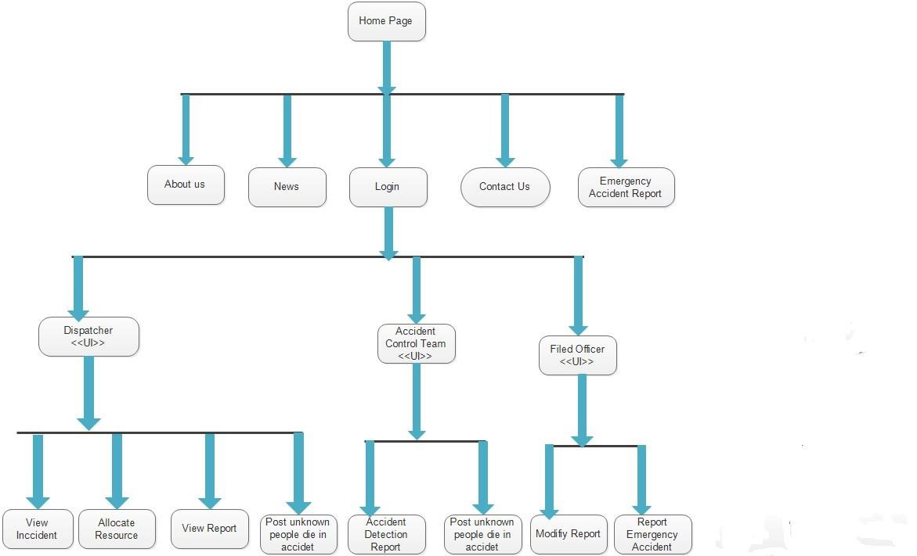

Figure 16User Interface Prototyping

**Chapter Four: System Design**

4.1 Introduction

System design is the transformationof the analysis model into a system design model. Up to now we were inthe problem domain. System design is the first part to get into thesolution domain in a software development. This chapter focuses ontransforming the analysis model into the design model that takes intoaccount the non-functional requirements and constraints described in theproblem statement and requirement analysis sections discussed earlier.The purpose of designing is to show the direction how the system is builtand to obtain clear and enough information needed to drive the actualimplementation of the system. It is based on understanding of the modelthe software built on. The objectives of design are to model the systemwith high quality. Implementing of high quality system depend on thenature of design created by the designer. If one wants to change to thesystem after it has been put in to operation depends on the quality of thesystem design. So if the system is design effetely, it will be easy to makechanges to it.

4.1.2 Design goals

These describe the qualities of the system that we should optimize Many design goals are inferred from the nonfunctional requirements or from the application domain.The new system is considered tobe successful if itmeetsthe followingsets of criteria’s.

* *User Interface*: The user interface of the system should be easy to use by each user of the system with little training.
* *Documentation:* System administrators and other users are provided with proper documentation about the software’s features.
* *Performance:* The system should be able to serve a number of users which are expected to access it concurrently.
* *Error Handling and Extreme conditions*: The system should be robust enough to handle error conditions and continue with normal operations.
* *Availability:* The system availability should be available most of the time since it is handling emergency situations.
* Security: The system should prevent the sensitive data from unauthorized access.
* *Modifiable*: The system should be designed in Object Oriented language so that modification to some part of the system could not affect other parts.

**4.2 Class type architecture**

A common architectural strategy,some might call it a pattern,is to layerthe architectureof a systeminto severallayers/strata.All types of classes may interact with system classes.This is because your system layer implements fundamentalsoftware features such as inter-process communication (IPC),a service classes use to collaborate with classeson other computers, and audit logging, whichclasses use to record critical actions taken by thesoftware. For example, if your user interface classes are running on apersonal computer (PC) and your domain classes are running on an EJBapplication server on another machine, and then your interface classes willsend messages to the domain classes via the IPC service in the systemlayer. This service is often implementedvia the use of middleware.

* **Interface layer**

This layer wraps access to the logic of your system. There are two categories of interface class– user interface (UI) classes that provide people access to your system andsystem interface (SI) classes that provide access to external systems to yoursystem. Java Server Pages (JSPs)and graphical user interface (GUI)screens implemented via the Swing class library are commonly used toimplement UI classes within Java. Web services and CORBA wrapperclasses are good options for implementingSIclasses.

* **Domain layer**

This layer implements the concepts pertinentto your business domain such as Student or Seminar, focusing on the data aspects of the business objects,plus behaviors specific to individual objects. Enterprise Java Bean (EJB) entity classes are acommon approach to implementing domainclasseswithinJava.

* **Process layer**

The process layer implements business logic that involves collaboratingwith several domain classes or even other processclasses.

* **Persistence layers**

Persistence layers encapsulate the capability to store, retrieve, and deleteobjects/data permanently without revealing details of the underlyingstorage technology. often implement between your object schema and yourdatabase schema and there are various available to you

* **System layer**

System classes provide operating-system-specific functionality for your applications, isolating your software from the operating system (OS) by wrapping OS-specific features, increasing the portability ofyourapplication.

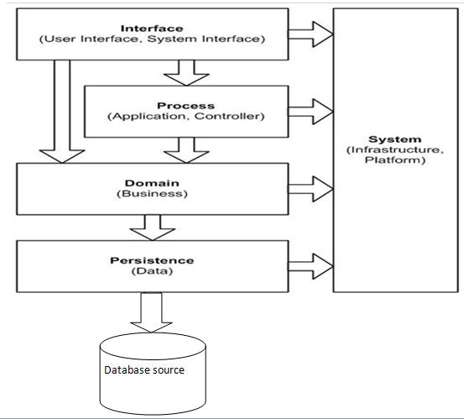

4.3 Class modeling

Class diagram shows the static structure of data and the operations that acton the data, i.e. it shows the static structure of an object-oriented model theobject class, their

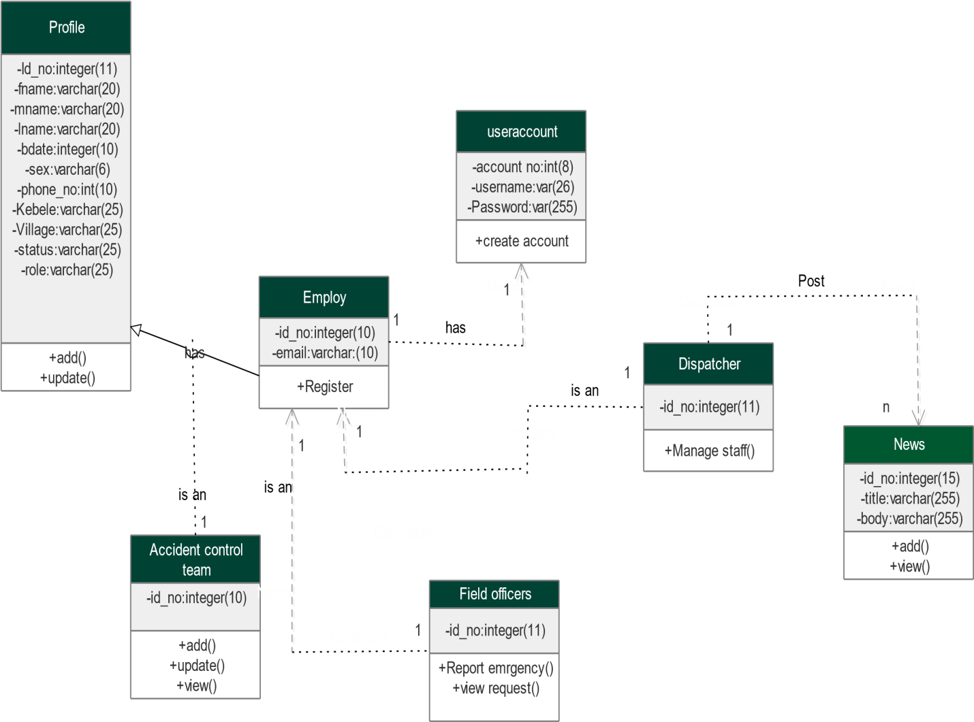

Fig 17 class diagram

4.4 State chart modeling

State chart diagram describes the flow of control of the kombolcha citypolice station accident management proposed system from one state toanother state to describe the system dynamically. States are defined as acondition in which an object exists and it changes when some event istriggered. So the most important purpose of State chart diagram is tomodel life time of an object from creationto terminal.

1 Login

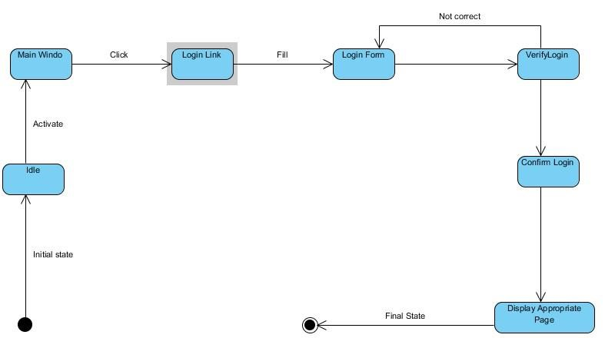

**Figure 11 state chart login diagram**

2 **View Report**

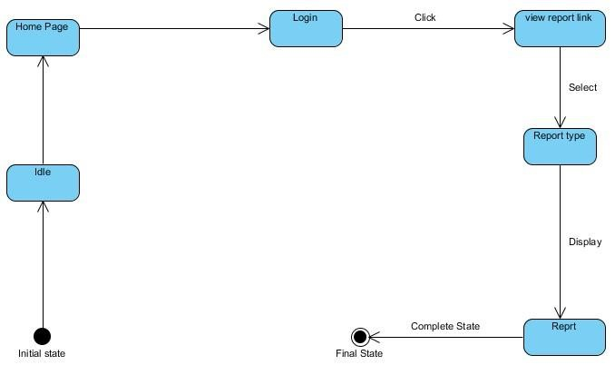

***Figure 12 view report***

**3 Post information**

**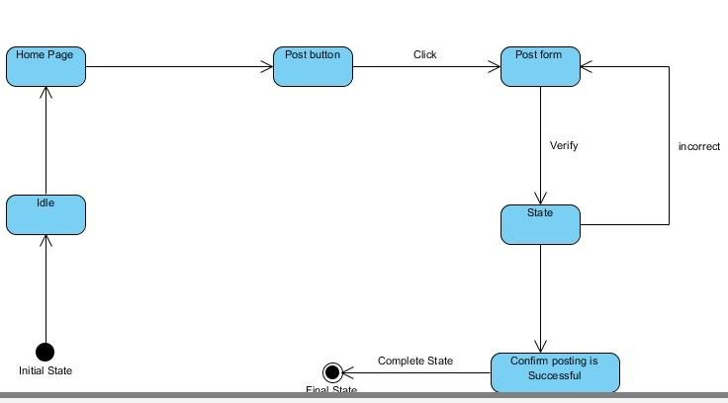*Figure 13 post information***

4.5Collaboration Modeling

Collaboration diagram shows the structural organization of objects thatsend and receive messages. Sequence and collaboration diagrams are jointly called interaction diagrams and they can be transformed one intoanother. The following are collaboration diagrams drawn for basic servicesof thesystem.

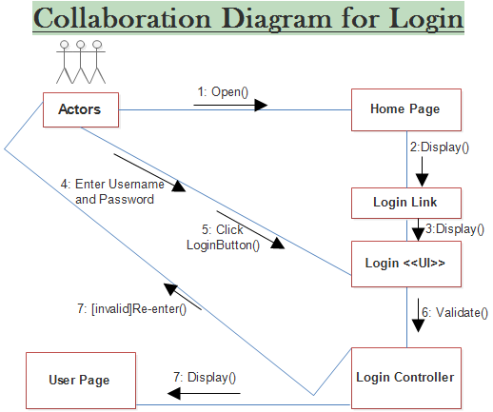

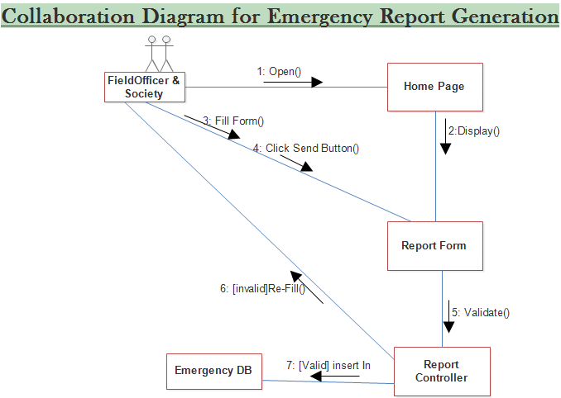

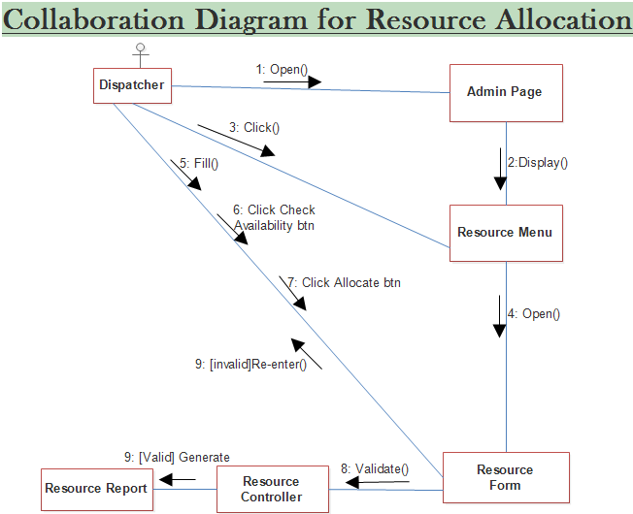

4.6 Component Modeling

By this Diagram, components of the system will be wired showing that there isrelation among components; management of the system, database and operations performed on databases such security issue. This in some extent shows which component or objects will be accessed by whom and what type of securityinfrastructures it is using Aniekwe Vivian Nkiruka - *August, 2012*. The component diagram of kombolcha police station accident management system isdisplayed below.



***Figure 19 component diagram***

4.7 Deployment modeling

Deployment diagrams model the physical architecture of a system, and it showsthe relationships between the software and hardware components in the systemand the physical distribution of the processing Aniekwe Vivian Nkiruka –*August,2012.*



***Figure 20 deployment diagram***

4.8 Persistence modeling

Persistent data management deals with how the system is going tohandle the actual data need to be stored on the database of the system. The purpose of persistence modeling is which objects in the system design are required to be stored persistently. Clearly, in a databasedriven application like this one, almost all system interactions have deal with persistent data. Online accident management system will largely depend on a relational database to perform day-today operations andstoring log data. Data will be stored in a MySQL Data Base Management system and manipulated through the Database Subsystem, which will ensure data integrity and consistency. Database Subsystemwill contain all necessary SQL queries that will be accessible by the rest of theSubsystems.

The data stored in the database will include:

* Emergency accident report
* User account
* Society
* Employ profile

4.9 User Interface design

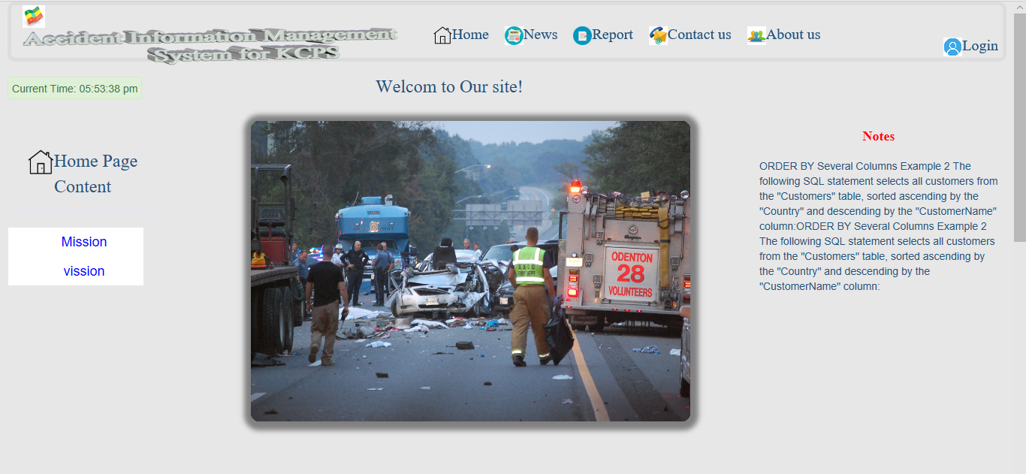

**Figure 14 User Interface and navigation for KCAIMS**

**Chapter Five: Implementation and Testing**

* 1. Introduction

Implementation refers to the Coding of the all documents gathered starting from requirement analysis to Design phase. So now the team is in a position ofconverting all documents gathered and designed into the code so that the system will be implemented for the user to be used for the purpose itdeveloped. To implement it the user must have usewebsite which havenetwork.The result of this phase consists of source code, together with documentation tomake the code more readable. This is what we call software implementation. The purpose of these activities is to convert the final physical systemspecification into working model with reliable software and hardware, document the work that has been done, and provide help for current and futureusers and take care ofthesystem.

* 1. Final Testing of the system

The team members test the whole system in the following procedures.

1. **Unit testing:** - the team member tests every module by applying some selection mechanism. Through this mechanism every modules gets tested. If an error occurs correction will be taken without affecting another module.

***Table 19 unit testing***

|  |  |  |  |
| --- | --- | --- | --- |
| Tested Form | Test Case | | Expected Result |
| Login Form | validate user name and  password entry as an input from each end users | | Display a message when user didn’t fill user name or password and also when there is user name or password error |
| All other forms | controlling the  insertion of data | proper | Display a message when user left some text fields, radio buttons, combo boxes or date and time unfilled and insert improper data in to the form try to save. |

1. **Integrated testing:** -

All the modules will be combined together and tested it for its fitness with each other and with the systems functionality. If error occurs in combining them, the module with problem will be identified and recombined.

***Table 20 integrated testing***

|  |  |  |
| --- | --- | --- |
| Tested Form | Test Case | Expected Result |
| Form splash | Check whether after splash login form is displayed or not | Display login form after the time delay that the splash displayed. |
| Login Form | Check the correctness of the form to be displayed after login is succeeded | Display administrator or system members menu |
| Administrator menu | check proper display of selected  options to be accessed | Display the selected form from the administrator form as menu |
| Report from | check whether the report will be  generated or not | The selected report will be displayed |
| All forms | check the navigation functionality | The form required Will be displayed |

1. **System testing:** - the team member to performs over all functional testing by checking whether it meets the required target or not. Here the system is partially functional and reached its requirement.

***Table 21 system testing***

|  |  |  |  |
| --- | --- | --- | --- |
| Tested from | Test case | Expected result | Actual result |
| Login form | To validate the proper functionality of login by inserting username and password | To authenticate user | user will be authenticated and if  user is authorized enter to the system else confirm invalidity |
| Search from | To validate the functionality of search form | Search result | If the requested record exist display the result else if it doesn’t exist display the message about the status |
| Report from | To validate the functionality of report form | To generate report | generate the requested report if the request is valid, if request is invalid display message box that describes the invalidity |
| All forms | To validate the functionality of each form | To provide the function  required by the form | The form is presented and the required function can operated using the form |

* 1. Hardware software acquisitions

Hardware software acquisitions determinethe systemresourcerequirements, its capabilitywith other systemsandnetworks,

its interface requirements to existing systems if any, its security capability, deficiencies and vulnerability and to make sure there are not already existing software/system that provide equivalent functionality. For the project implementation the following Software and hardware are used.

Hardware

* Computers

Software tools:

* Browsers (Mozilla Firefox, Google chrome)
* Notepad++
* Sublime text
* Xampp
* Microsoft word
* Notepad
* Edraw Max
* Visual paradigm for UML diagram.
  1. User manual preparation

**For society/user: -**someone wants to report some accident follow the following step

Step1:-For society wants to report some accident in her/him around first enter to kombolcha city police station website.



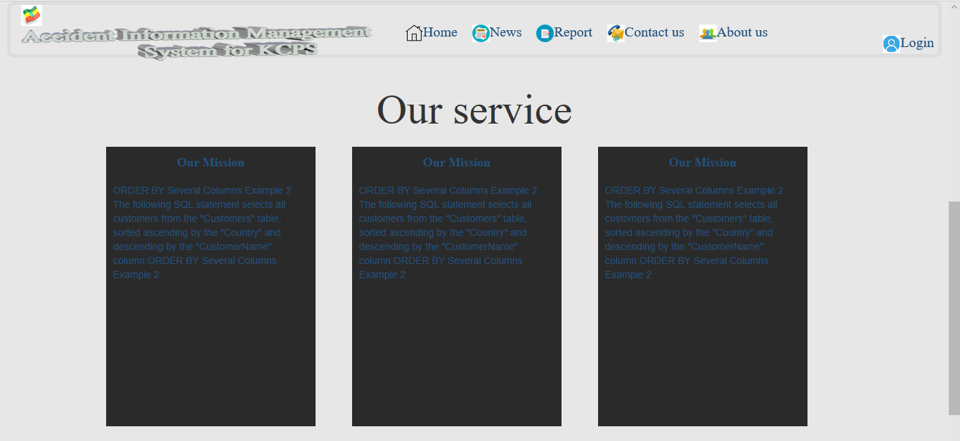

***Figure 23 user manual preparation***

Step2:-Then he/she click the emergency accident request link then the system displays the form if he/she want to report see some accident.

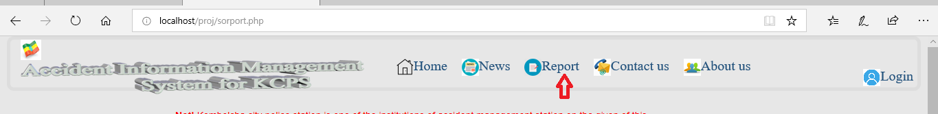

Step3:- He/she fill the necessary information properly.

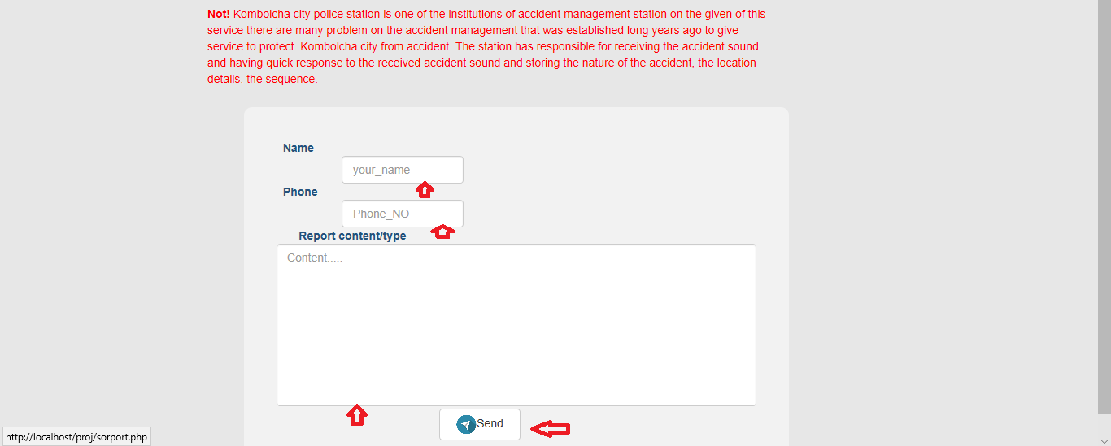

***Figure 24 accident request page***

Step4:-If the user/society enter the information correctly the system displays the success message otherwise the system display dose not sent the request.



***Figure 25pictuer responding from system***

Login using your username and password to: -

Field officer: -

Step1:-Login using your username and password to:

* Report the emergency accident.
* View request

For example filed officer to change his password follow the following step Step1:- to access the system must be have username and password then enter the password and username.

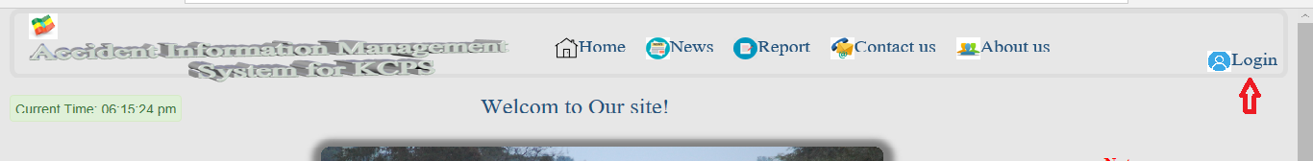

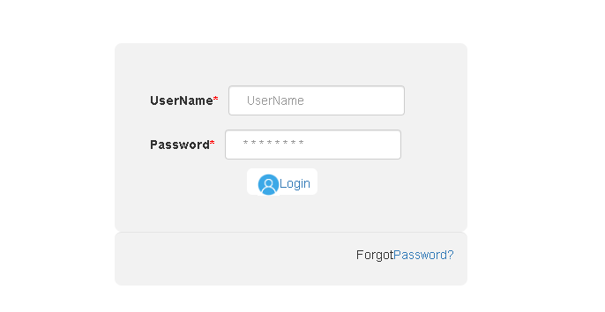

***Figure 26 login form***

If you insert wrong username and password the system displays the following.

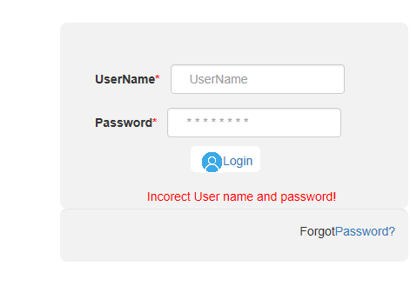

***Figure 27 the system responding***

Step-2- Entering in to the system: If you enter the correct username and password in to the login page it brings to the main page safely. It seems the following.

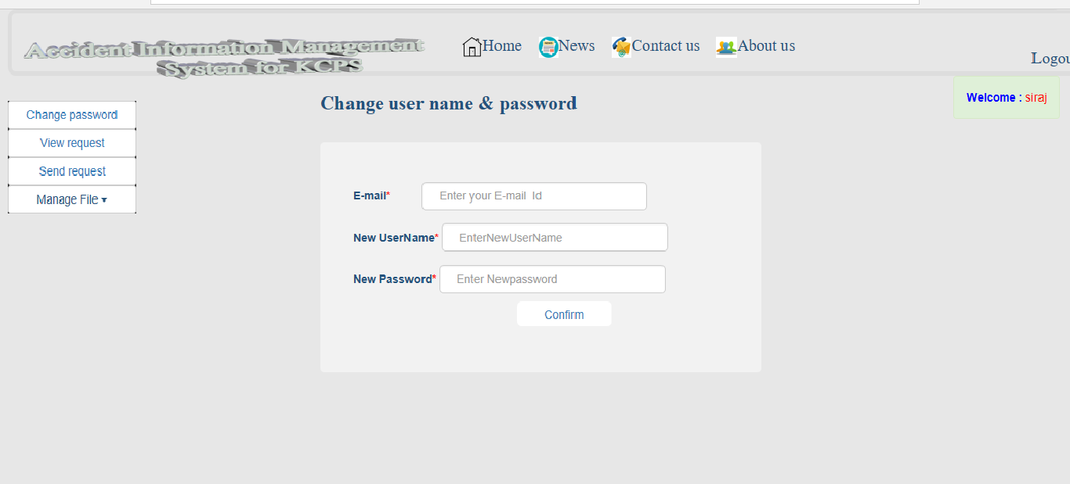

*Figure 28 accident control team page*

Step3:-The Teamcontroler enter to system he done on him privilege.For example he wants to change his password he click the password button.

***Figure 29 password change picture***

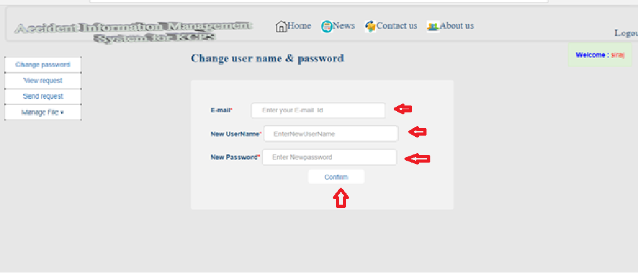

Accident control team: -

Login using your username and password to: -

* View request sent from dispatcher
* open Request to Teamcontroler
* change password
* add new accident file
* update accident file
* view the accident file
* Delete the accident file

**Dispatcher:** -Login using your username and password to: -

* Post news
* Add new employ to system
* View the emergency request sent from the society and respond to accident control team.
* Allocate Resource
* Create the user account
* Update the user account
* Delete the user account
* View user account
* Manage the staff for example the dispatcher wants to see the request pass the following step

Step1:-first he/she should be login to system

Step2:-if he/she enter the user name and password incorrect the system display message.



***Figure 33 system respond accept the request***

Step3:-The dispatcher enter the user name and password correct he/she get the following page.

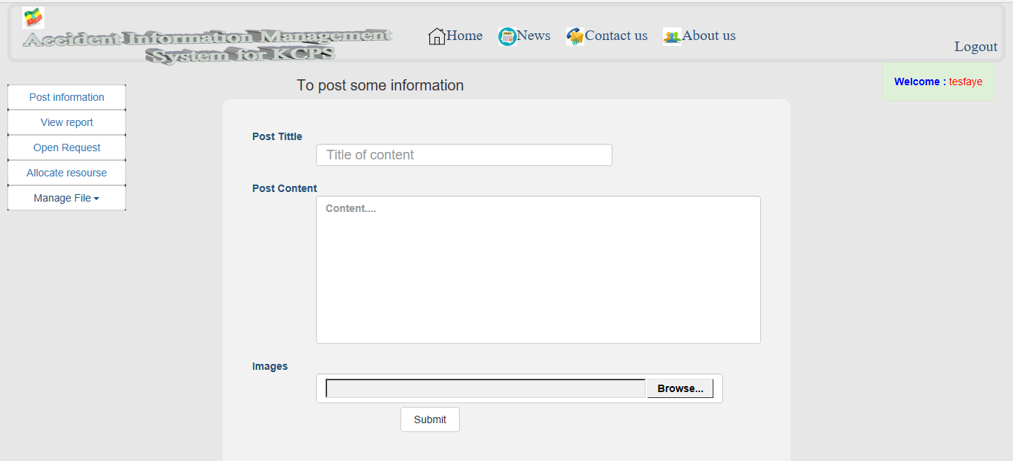

**Figure 34 dispatcher home page**

5.5 Training

Underlying success in most jobs roles is governed by the effective processes. These are often organizational specific. That might be the process you use, or how you use a specific engineering process to achieve a competitive advantage.

If we need people to apply that process we need to train the users of the system effectively.

Challenges in system and process training can include:

**Consistency**: - we make sure everyone’s learning the same best practice..

**Activation**: - it’s not just about understanding. It’s about taking responsibility for application of your processes and procedures, and knowing how and when to use the right ones.

**Ongoing access**: - make sure reminders are on tap at the point of need.

6.5.1 Training strategy

The organization user group might have a different training strategy although there would be a lot in common.

***End-user training:*** End-user training will be provided using a separate modules and departments. This system allows the creation of web-based content and provides a step-bystep walk through of the business process. Custom text, tips and explanations can be included in the recorded process. In our system the end user include the society or the user we learn how to use the system and changing in the awareness about only use the request button if some accident happen only.

***Technology:***

* The developer will install the system on the server.
* The system content will be published on a set schedules using the modules on the server
* Ensure uses have logon access
* End users will access training materials through web browsers➢ Ensure server has capability to handle usage ***Timeline:***
* Training materials will be developed during prototyping and configuration
* Training materials will be available for experts and users who will be enlisted to conduct the system integration test and a full training package will be in
* Training should be done before the system go-live for the operational offices. ➢of the system ***Trainer:***
* Project managers will determine who will conduct the training
* The stakeholder will determine who will be trained for a specific module.

***Resources***:

* Determine who will maintain training materials as editing is needed.
* Determine how to identify when edits are needed
* Training manager will be the point of contact for edits, changes, revisions and publish schedules.  ***Location:***
* Trainers will determine where training will be held
* The organization will locate training site for their users ***Evaluate training:***
* After system testing solicit feedback to determine next steps
* Respond to areas that need more attention
* Make required changes per user feedback
* Announce what changes or edits were made ***User acceptance testing:***
* We will create user acceptance testing prior to delivery
* Edit and modify system documentation when needed

5.6 Installation Process

**Required items to request an agent installation:**

To request a web based installation, we need to provide the following information:

* Name of organization requesting the installation
* Ip address of the server being protected
* Host name of the servers
* URL being protected
* Operating system of the web application server being protected. Give the specific version of windows, Linux, or Unix, specify whether 32/64 bit
* Type of web application server (Apache)

5.7 Start-up strategy

# *The start-up strategy will be*:

* Buying a domain name
* Hosting the system
* Finally available internet connection

**Chapter Six: Conclusions and Recommandation**

* 1. Conclusions

Implementing the analyzed and designed online accident management system might be the best solution to the current major Kombolcha police station problem, as it will provide online reported the accident, so that the society can inform from home or anywhere else via such system. Accident Management System allows police department to store department’s accident details, Complaint Details, report store details, etc. This Software Package allows Police Departments to store all the details related to the department and use them whenever necessary. This project will also be able to provide reports of various accident type, accident report, and also be able to upload and view known people die in accident, and hot news. The implementation of the system in the organization will considerably reduce manual data entry, time and also provide readily calculated reports.

*6.2*Recommandations

The system that we have developed involves web based accident management system for

Kombolcha city police station that means it’s a huge system so it is very difficult to include all functionality of the police station office so that we only concerned on the online emergency accident report, record the accident file, and prepare report and easily recording the accident management employs. Subsystems because of limited development capacity and time. Therefore, we recommend the following features need to be included in any further revision and extension attempt.

* May used the web base to change in to android or mobile based application.
* Include the crime management system.
* Use uninterruptible power supply or UPS if electric power is not available in station
* Integrate with the court system.
* Adding the chatting system.
* System allocate the resource based on the accident weight and level of the accident.
* They done all system in police station are automated
* Handle the society use the request page for emergency purpose only.
* Update this system to android based system or integrate with android and PHP.
* May used location based telephone number calling, this mans for example there are three police station in Kobolcha city, all the telephone number of police station record in database, using android application to call from initial distance to police station comparing which police station are near to initial point it calling comparing the distance between them. The user only click the application system the system calling by itself. Therefore, others who are interested to develop a new system on police station accident management system or other related systems can get some initial idea about the system. By focusing on the limitation and functional areas of the system they can also develop a better police station management system that automates all files managed in police station and other related thin
* Appendix

Appendix A:Paper Document in the Existing SystemAccident report formfor Kombolcha city police station

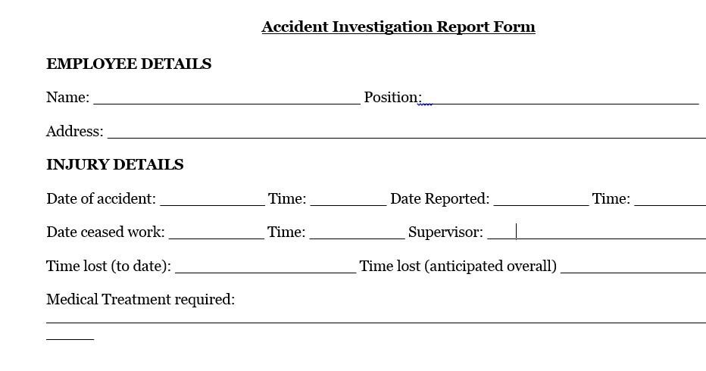

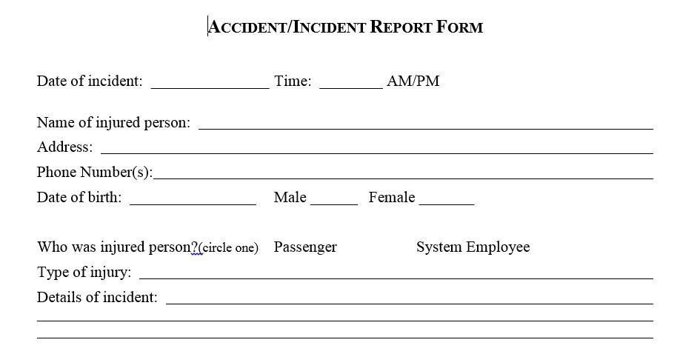

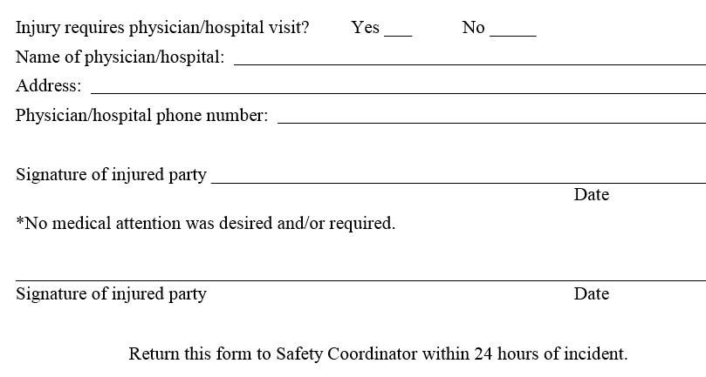

* Références